
National University of Computer and Emerging Sciences Chiniot-Faisalabad Campus
BS (Artificial Intelligence)

Name | MUZAMMIL BIN SOHAIL
Reg. No. | 22F-3110
Section | BS(AI) SECTION 4A
Course | DB
Lab | 12
Department | Artificial Intelligence & Data Science

Task 1:
CREATE OR REPLACE PROCEDURE MINIMAX(EMP_NO IN NUMBER) AS
MIN_SAL NUMBER;
MAX_SAL NUMBER;
BEGIN
SELECT MIN(SAL), MAX(SAL)
INTO MIN_SAL, MAX_SAL
FROM EMP
WHERE EMPNO = EMP_NO;

DBMS_OUTPUT.PUT_LINE('Lowest Salary of Employee :' || EMP_NO || ': ' || MIN_SAL);
DBMS_OUTPUT.PUT_LINE('Highest Salary of Employee :' || EMP_NO || ': ' || MAX_SAL);
END;
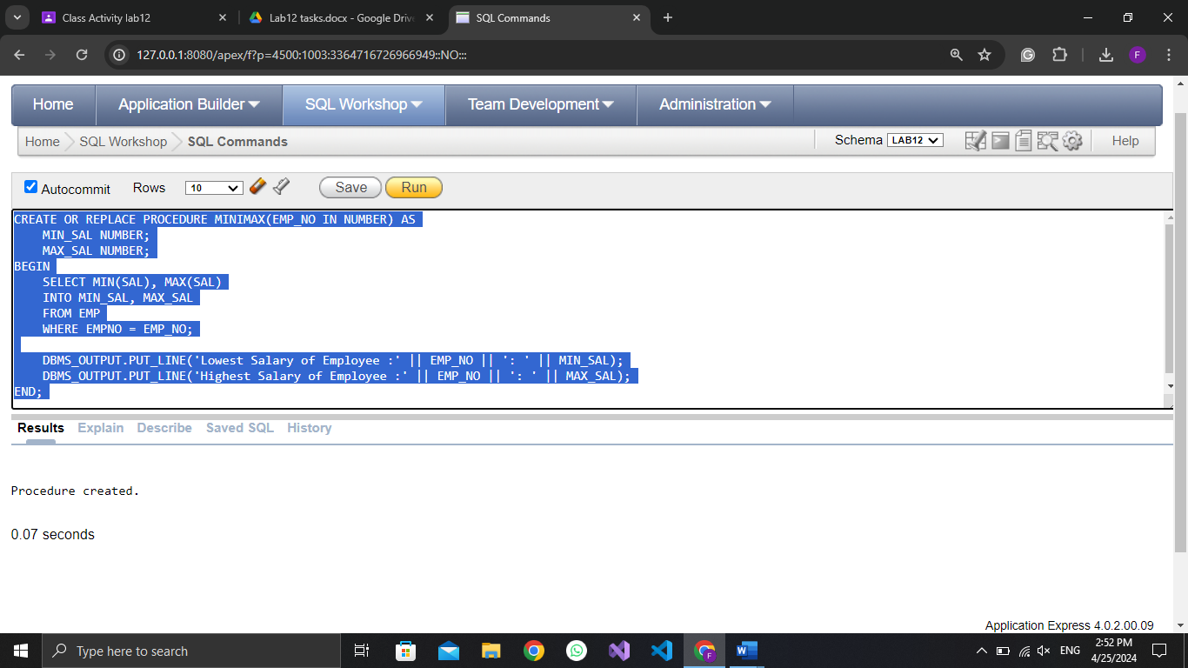

BEGIN
minimax(7839);
END;
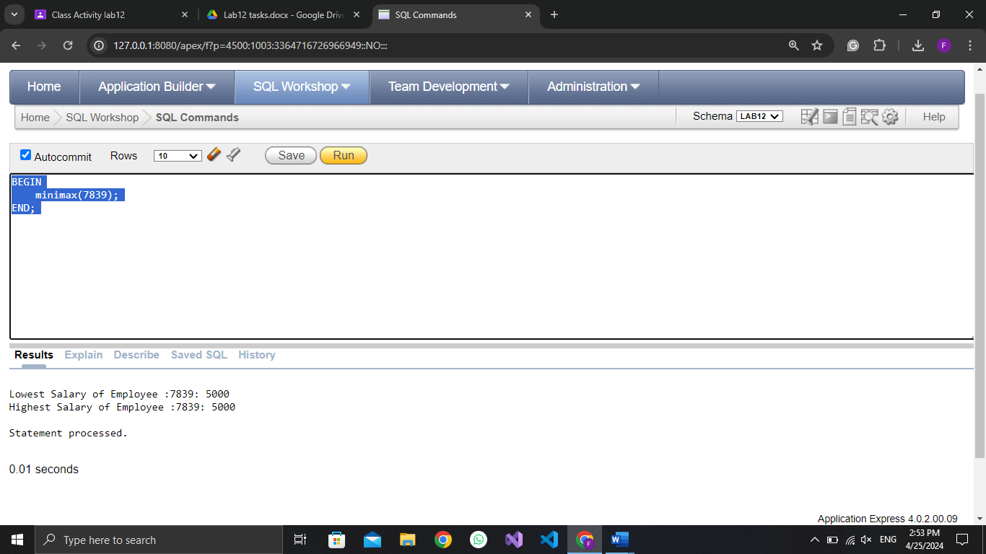
Task 2:
CREATE OR REPLACE PROCEDURE INCREASESALARY(
EMP_ID IN NUMBER,
PERCENTAGE_INCREASE IN NUMBER
)
AS
CURRENT_SALARY NUMBER;
NEW_SALARY NUMBER;
BEGIN
SELECT SAL INTO CURRENT_SALARY FROM EMP WHERE EMPNO = EMP_ID;

NEW_SALARY := CURRENT_SALARY * (1 + PERCENTAGE_INCREASE / 100);

UPDATE EMP SET SAL = NEW_SALARY WHERE EMPNO = EMP_ID;

DBMS_OUTPUT.PUT_LINE('SALARY FOR EMPLOYEE ' || EMP_ID || ' INCREASED TO ' || NEW_SALARY);
END;
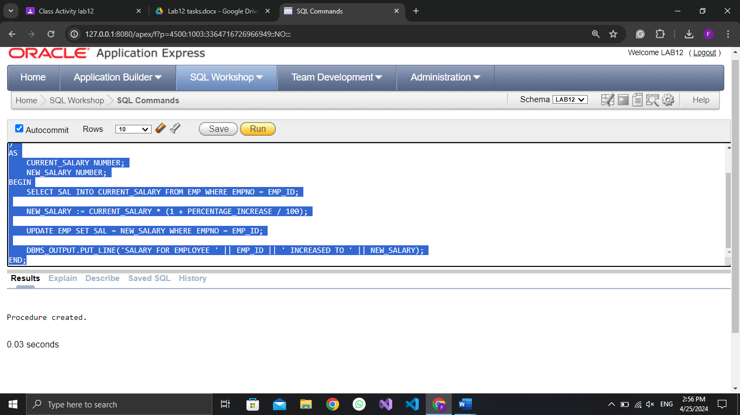
BEGIN
INCREASESALARY(7839, 30);
END;
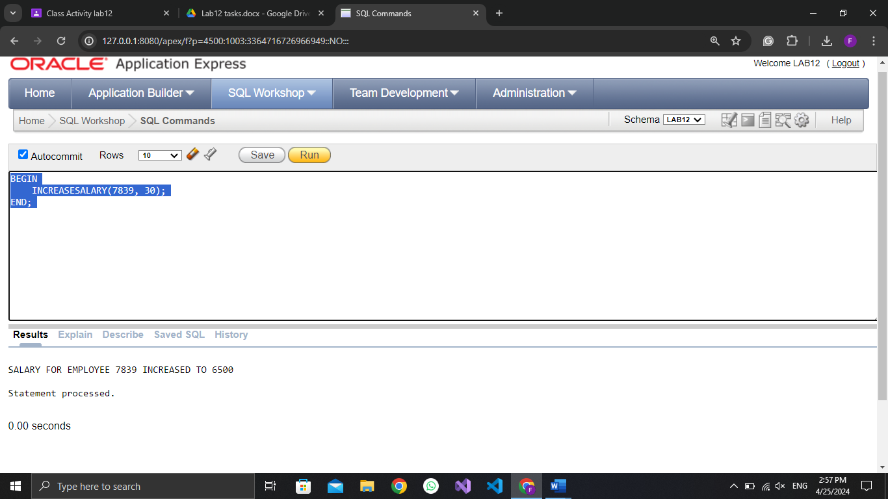

Task 3:
CREATE OR REPLACE FUNCTION REVERSENUMBER(num IN NUMBER) RETURN NUMBER IS
REVERSED_NUM NUMBER := 0;
TEMP_NUM NUMBER := num;
BEGIN
WHILE TEMP_NUM > 0 LOOP
REVERSED_NUM := (REVERSED_NUM * 10) + MOD(TEMP_NUM, 10);
TEMP_NUM := TRUNC(TEMP_NUM / 10);
END LOOP;

DBMS_OUTPUT.PUT_LINE('REVERSED NUMBER: ' || TO_CHAR(REVERSED_NUM));

RETURN REVERSED_NUM;
END;
/
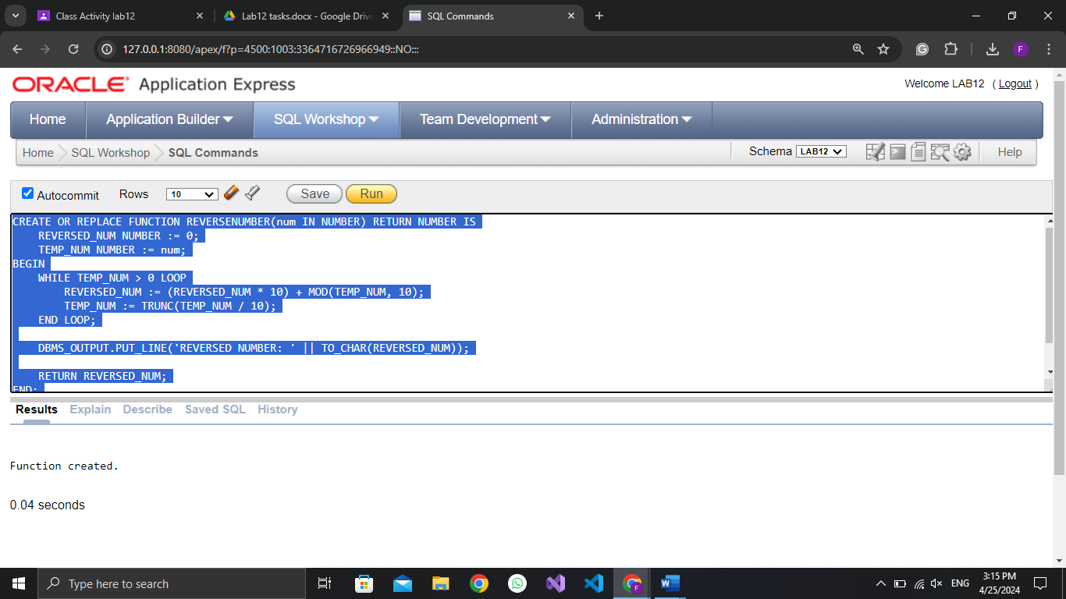
DECLARE
INPUT_NUMBER NUMBER := 123;
REVERSED_RESULT NUMBER;
BEGIN
REVERSED_RESULT := REVERSENUMBER(INPUT_NUMBER); -- CALL THE FUNCTION AND GET THE REVERSED NUMBER
END;
/
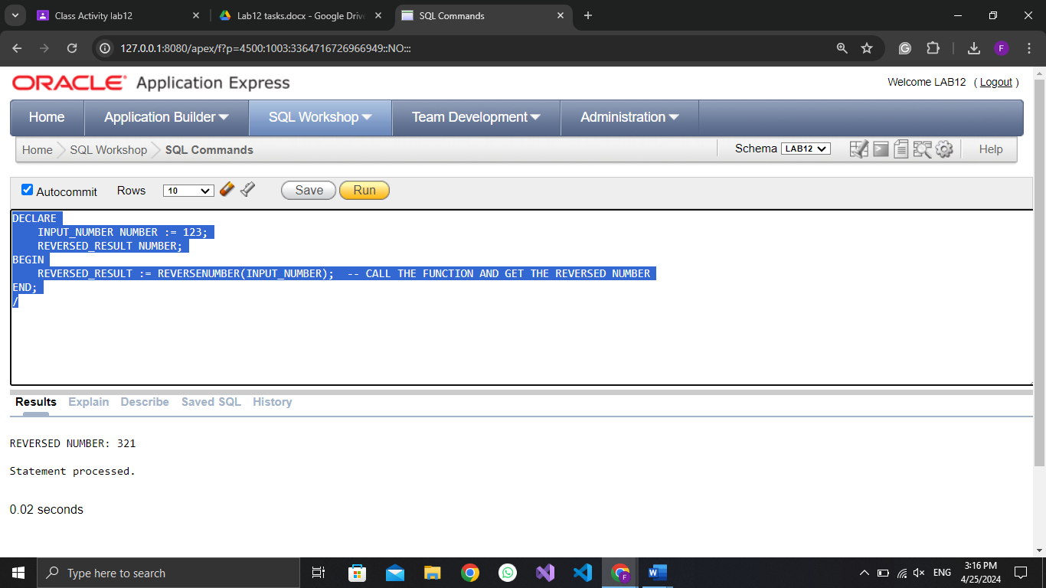

Task 4:
CREATE OR REPLACE FUNCTION GETDEPARTMENTMANAGER(
DEPT_ID IN NUMBER
) RETURN VARCHAR2 IS
MANAGER_NAME VARCHAR2(100);
BEGIN
SELECT E.ENAME INTO MANAGER_NAME
FROM EMP E
WHERE E.EMPNO = (SELECT MGR FROM EMP WHERE DEPTNO = DEPT_ID AND ROWNUM = 1);

RETURN MANAGER_NAME;
EXCEPTION
WHEN NO_DATA_FOUND THEN
RETURN 'NO MANAGER FOUND FOR DEPARTMENT ' || DEPT_ID;
END;
/
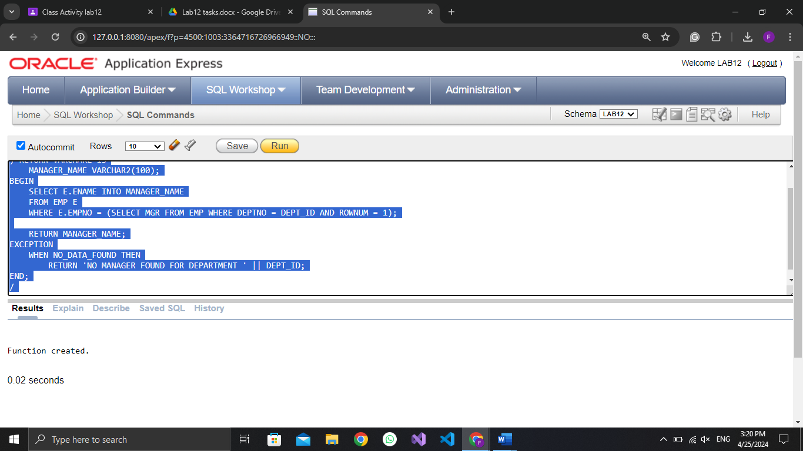

DECLARE
DEPARTMENT_ID NUMBER := 12;
MANAGER_NAME VARCHAR2(100);
BEGIN
MANAGER_NAME := GETDEPARTMENTMANAGER(DEPARTMENT_ID);
DBMS_OUTPUT.PUT_LINE('MANAGER OF DEPARTMENT ' || DEPARTMENT_ID || ': ' || MANAGER_NAME);
END;
/
